TEAM ARBITRARY

Professional Development Notebook

Systems Requirements Report

April 5, 2022

Development Team: Josie Henvey, Yuzhen Zhang, Josh Riddle

**INTRODUCTION**

This document outlines the requirements for a system to record and display submitted forms. In the Professional Development Committee (PDC), members fill out an attendance form with data pertaining to a single professional development session. This document is created and submitted through Google Forms.

Currently, there is no way for members of the PDC to view previously submitted forms. A PDC member would have to keep a personal record of the data that they are logging, a process which is time consuming and unlikely due to a lack of software to assist the member.

The goal of this program is to allow members to view their submitted forms, and thus, track their own data and progress within the PDC.

**ACTIVITY DIAGRAMS**

Below are swim lane diagrams to demonstrate the current process and proposed process flows. The proposed system does increase the amount of steps taken, however, at a virtually insignificant increase in the time taken to input data, with the added benefit being the ability to view previously submitted forms.

**Current Business Process**

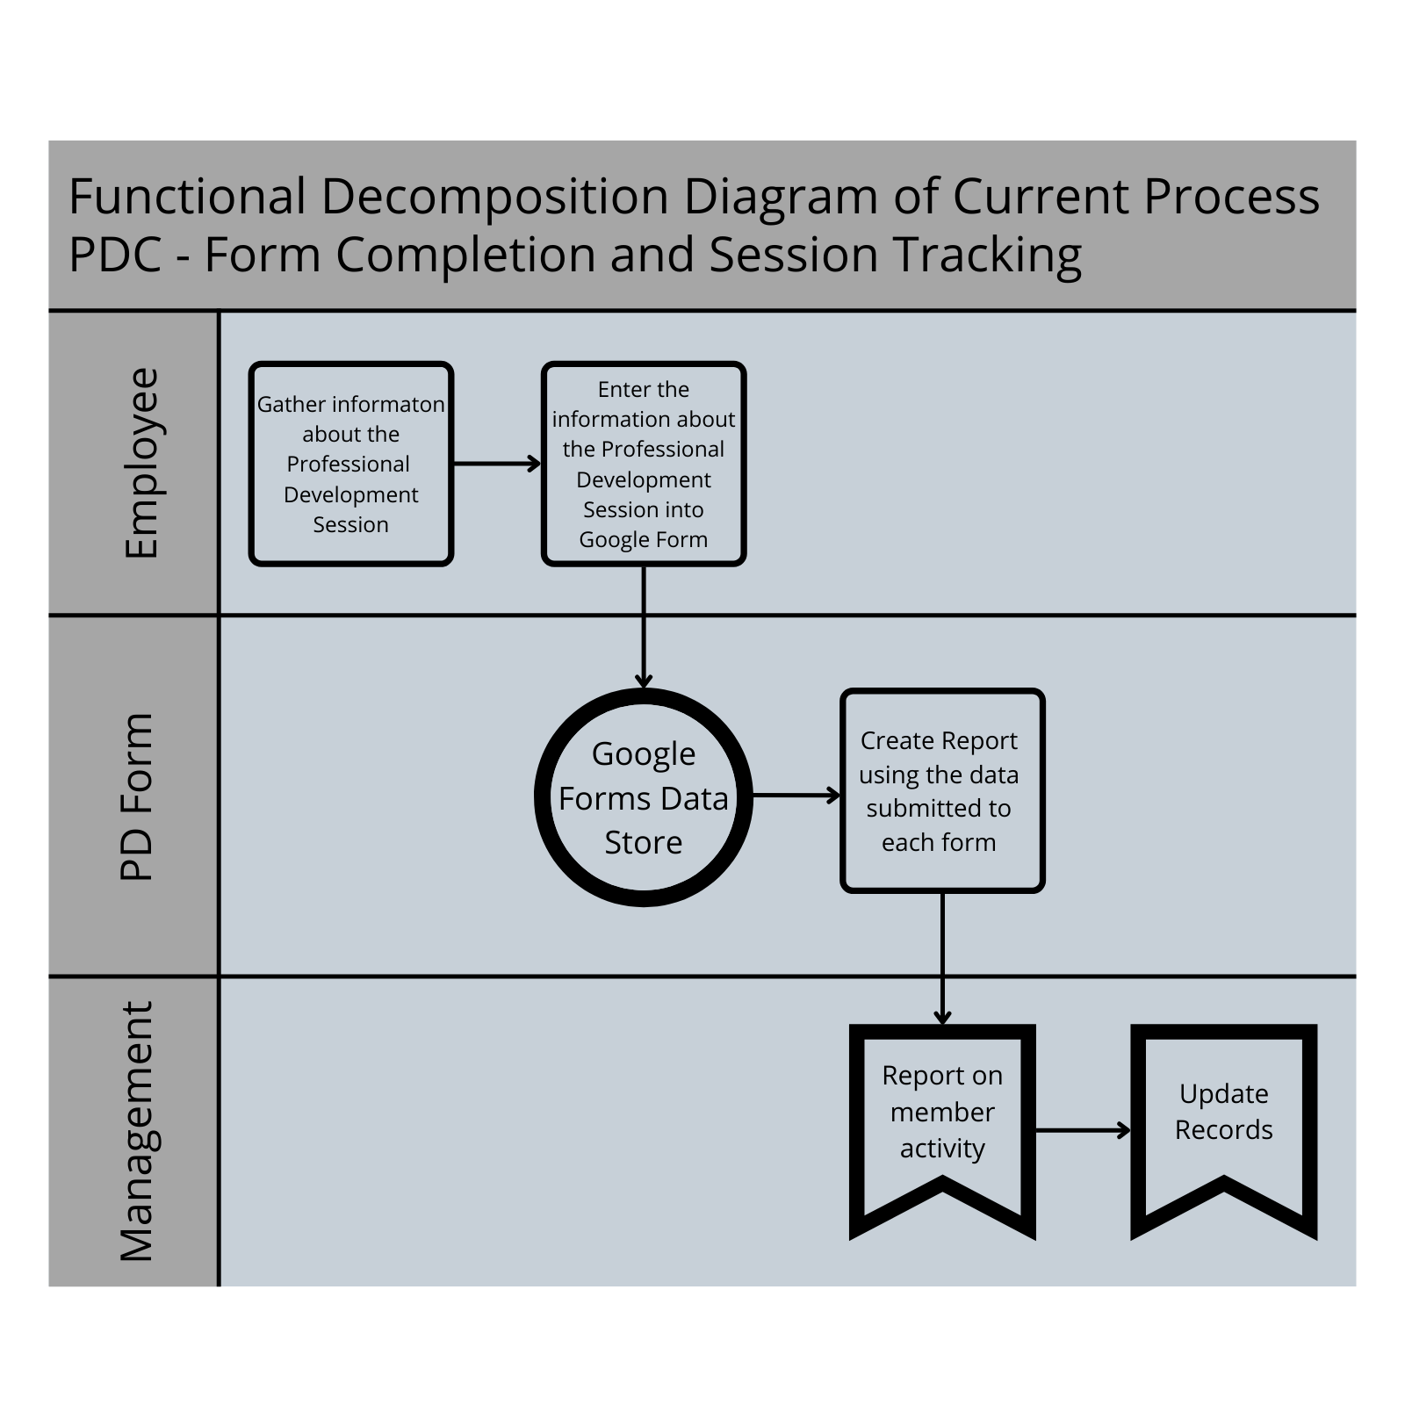

**Proposed Business Process**

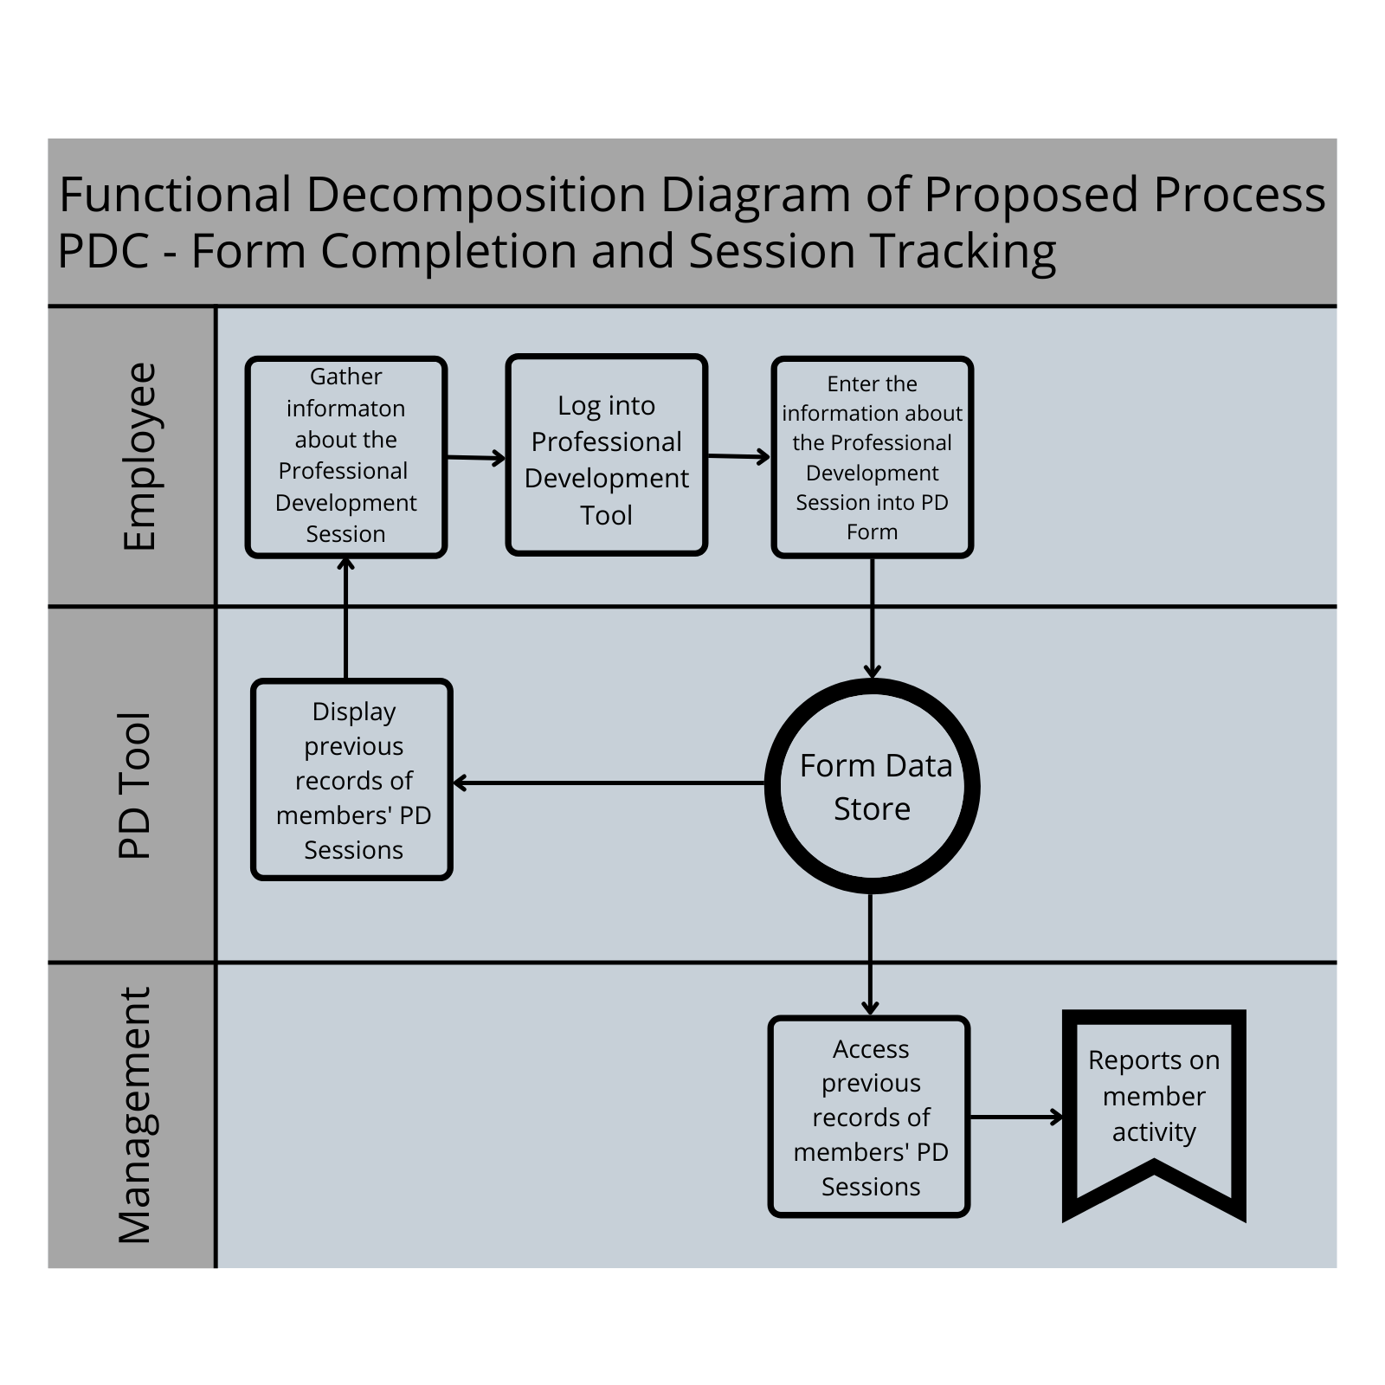

**DATA FLOW DIAGRAMS**

Below demonstrates data flow of the new system. The actual design of storage solutions, for example, will be addressed in the design phase of the systems development life cycle.

**Context Diagram**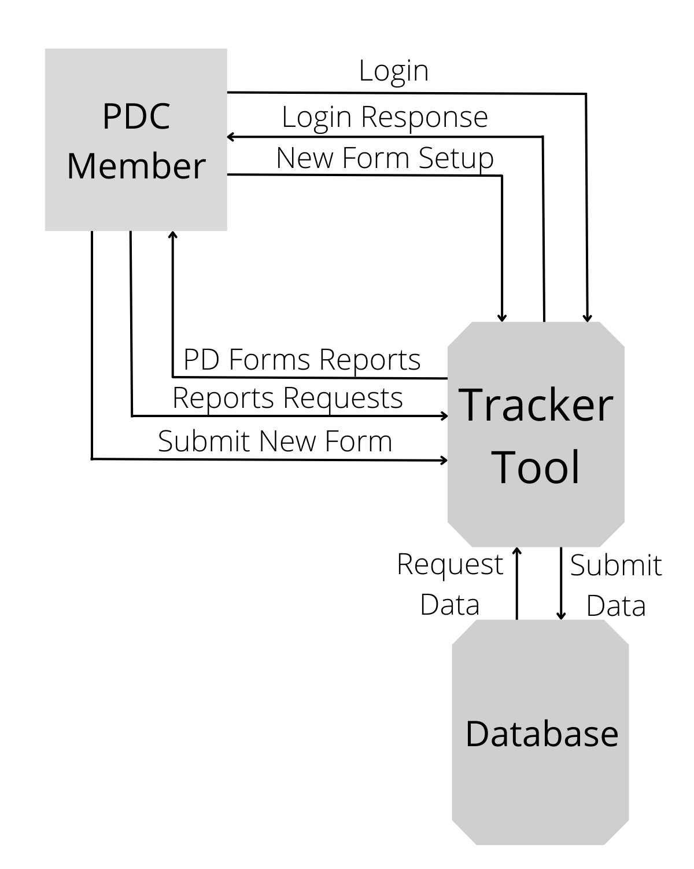

**FUNCTIONAL REQUIREMENTS TABLE**

**CONCLUSION**

The Professional Development Tracking Tool will take the process of creating and submitting progress forms and will allow the user to view the forms that they have submitted. As of right now, this is not possible.